Q.)

create table employee(

Employee_ID int primary key,

Employee_Name varchar(10) not null,

Job_Title varchar(10) not null,

Salary int not null,

Bonus int,

Age int not null,

Manager_ID int

);

insert into employee values (1201, "Divya", "President", 50000, NULL, 29,NULL), (1205, "Amyra", "Manager", 30000, 2500, 26,1201), (1211,"Rahul", "Analyst", 20000, 1500, 23,15205), (1213, "Manish", "Salesman", 15000, NULL, 22,1205), (1216, "Megha", "Analyst", 22000, 1300, 25,1201), (1217, "Mohit", "Salesman",16000, NULL, 22,1205);

select * from employee;

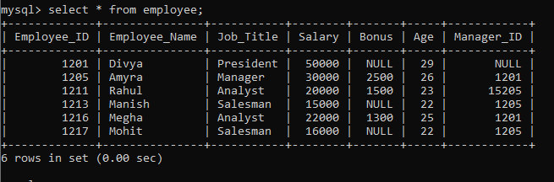

delete from employee where Employee_ID = 1217;

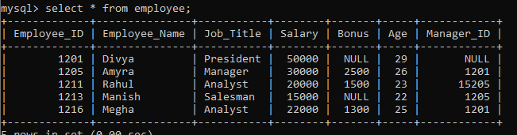

update employee set salary = 40000 where Employee_Name = "Amyra";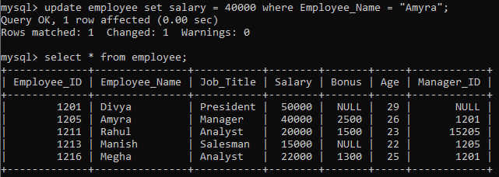

create table employee(

Job_ID int primary key,

Job_Title varchar(10) not null,

Min_Salary int not null,

Max_Salary int not null

);

insert into employee values (1001 , "Officer", 20000, 30000),(1002 , "Manager", 50000, 70000),(1003 , "Lead", 30000, 50000),(1004 , "Manager", 50000, 70000),(10055 , "Employee", 15000, 20000);

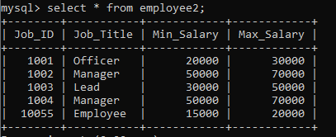

select Job_Title, Max_Salary from employee where Job_Title = "Manager";

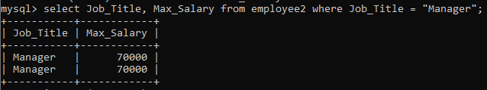

select Max_Salary from employee where Max_Salary between 30000 and 50000;

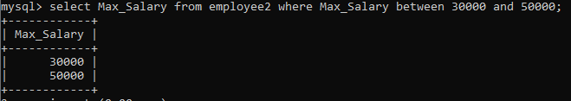

create table employee(

Employee_ID int primary key,

First_name varchar(10) not null,

Last_name varchar(10) not null,

Salary int not null,

Joining_Date DATE,

Department varchar(10)

);

insert into employee values (1, "Bob", "Kinto", 100000, 20210120,"Finance"), (2, "Jerry", "Kanaxo", 120000, 20200101,"IT"), (3, "Philip", "Jose", 2300000, 20210207,"Banking"), (4, "John", "Abraham", 800000, 20210609,"Insurance"), (5, "Micheal", "Mathew", 300000, 20210930,"Finance"), (6, "Alex", "Chreketo", 50000, 20211010,"IT"), (7, "Yohan", "Soso", 78000, 20210411,"Banking");

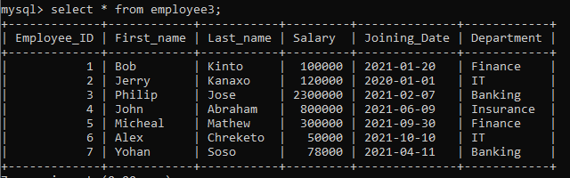

select distinct(Department) from employee;

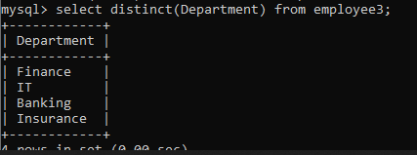

select First_name, Last_name from employee;

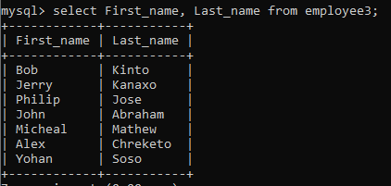

create table Countries(

Country_ID varchar(3),

Country_Name varchar(10) not null,

Region_ID int,

primary key(Country_ID, Region_ID)

);

insert into Countries values ("C01", "India", 1001), ("C02", "Italy", 1002), ("C03", "China", 1003), ("C04", "Brazil", 1004), ("C05", "Canada", 1005);

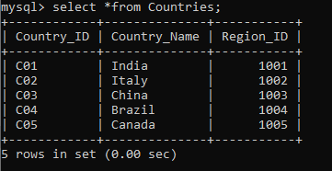

select * from Countries order by Country_ID desc;

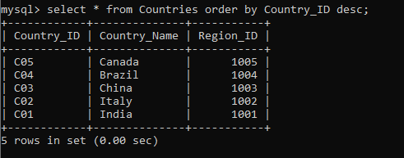

select Country_Name from Countries where Country_Name like "I%" ;

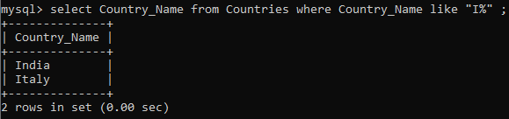

RENAME TABLE Countries TO new_country;

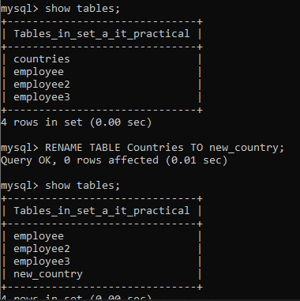

Q.)

create table Bank_details(

Ac_no int primary key,

Client_Name varchar(10) not null,

Balance int,

Locker_available varchar(3)

);

insert into Bank_details values (00169, "Ram", 69000, "YES"), (00170, "Shyam", NULL, "NO"),(00171, "Radha", 7000, "YES"),(00172, "Sita",50000, "YES");

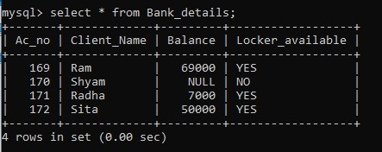

update Bank_details set Balance = 35000 where Client_Name = "Shyam";

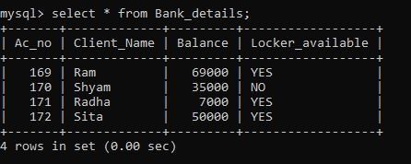

select * from Bank_details where Balance between 30000 and 50000; 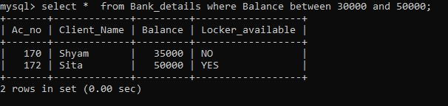

create table Menu_list(

ID varchar(4) primary key,

Item varchar(20) not null,

Description varchar(20) not null,

Price int not null

);

insert into Menu_list values("P001", "Sambhar Vada", "South Indian", 40),("P002", "Dal Maakhani", "North Indian", 150),("P003", "Noodles", "Chinese", 100),("P004", "Idli Sambhar", "South Indian", 50), ("P005", "Sarson Saag", "North Indian", 170), ("P006", "Dosa", "South Indian", 120), ("P007", "Pizza", "Italian", 200);

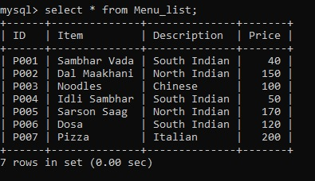

insert into Menu_list values("P009", "Lemon Rice", "South Indian", 140);

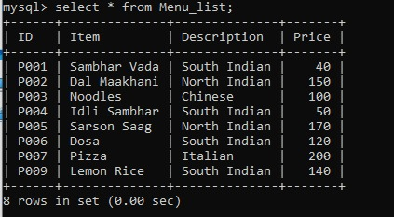

select * from Menu_list order by Price desc;

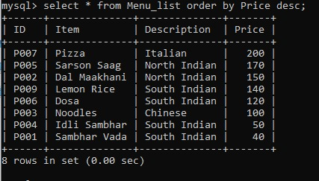

select Item, Description from Menu_list where Price between 100 and 150;

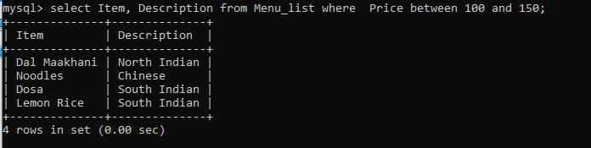

create table Employee_details(

EmployeeId int,

Name varchar(10) not null,

Email_Id varchar(90) not null,

Contact_no int not null

);

insert into Employee_details values (101, "Aakash", "akash@gmail.com", 909090990), (102, "Dharti", "dharti@gmail.com", 808080880), (104, "Sagar", "sagar@yahoo.com", 737373777), (105, "Agni", "agni@yahoo.com", 898999123);

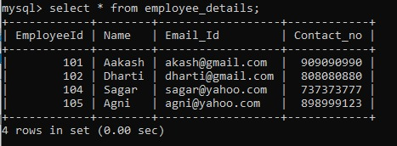

alter table Employee_details add primary key (EmployeeId);

desc Employee_details;

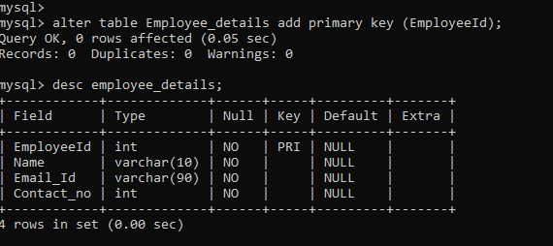

update Employee_details set Contact_no = 7077077077 where Name = "Dharti";

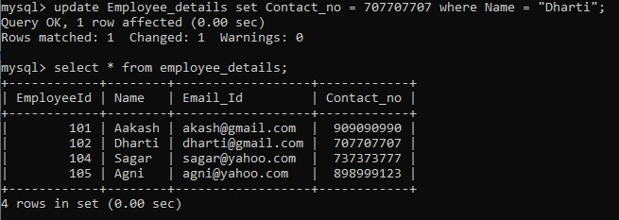

create table Travel_Agency(

Flight_no int primary key,

Type varchar(15) not null,

Location varchar(40) not null,

Price int not null

);

insert into Travel_Agency values (1234, "Domestic", "Pune - Mumbai", 12300), (231, "International", "Pune - Dubai", 73000),(4567, "Domestic", "Pune - Hyderabad", 8900),(007, "International", "Pune - New York", 112000),(919, "Domestic", "Pune - Delhi", 9300), (788, "Domestic", "Pune - Banglore", 6000);

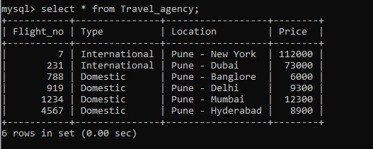

select * from Travel_Agency where Type = "International";

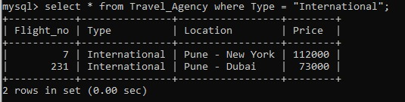

select * from Travel_Agency order by Price desc;

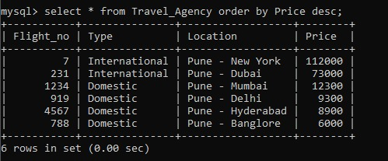

Q.)

create databse Blood_reports;

use Blood_reports;

create table reports(

Client_no int primary key,

Name varchar(10) not null,

Hb int not null

);

insert into reports values (123, "Abhay", 14.1), (124, "Vinaya", 12.2), (125, "Jabar", 14.1), (126, "Neema", 9);

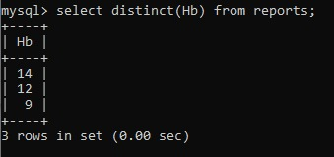

select distinct(Hb) from reports;



create table Employee_salary(

Job_ID int primary key,

Job_Title varchar(10) not null,

Min_Salary int not null,

Max_Salary int not null

);

insert into Employee_salary values (1001, "Officer", 20000, 30000), (1002, "Manager", 50000, 70000), (1003, "Lead", 30000, 50000), (1004, "Manager", 50000, 70000), (1005, "Employee", 15000, 20000);

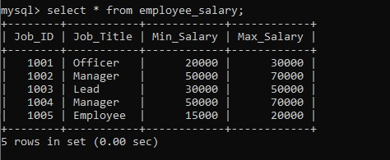

select Job_Title, Max_Salary from Employee_salary where Job_Title = "Manager";

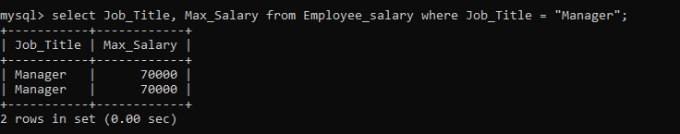

select Max_Salary from Employee_salary where Max_Salary between 30000 and 50000;

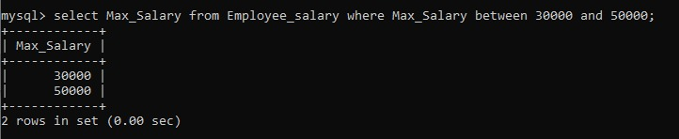

create database school;

use school;

create table Students(

Roll_no int primary key,

Std varchar(10) not null,

Division char not null,

First_name varchar(10) not null,

Last_name varchar(10) not null,

Date_Of_Birth Date not null

);

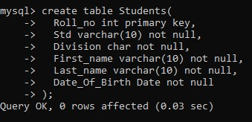

insert into Students values (1, "XII", "A", "Farah", "Shaikh", 19991111), (2, "XII", "B", "Afzal", "Hasan", 20121212),(3, "XII", "B", "Aradhna", "Shukla", 19990910);

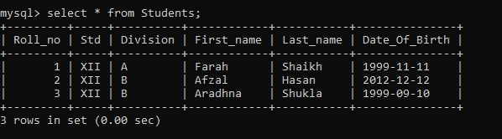

show databases;

use kshitij2;

